Test Cases Execution Report
Project: World Wide NDT Institute & Services Portal Verification
Test case No. | name | Test Objective | Test Steps | Issues | Status (Fixed or Not) | screenshot
tc01 | Verify Footer Copyright & Link Text Alignment | To ensure the footer text matches the requirement and is displayed in a single line as per the provided string. | 1. Navigate to the website's homepage.  2. Scroll down to the footer section.  3. Visually inspect the text in the bottom-most row of the footer.  4. Compare the actual displayed text with the required string: "© 2026 World Wide NDT Institute & Services. All Rights Reserved. Privacy Policy Terms of Service Admin Portal Design and Developed by WebNxt" | FAILED. The actual footer displays the links in multiple rows with separators (pipes). It is not a continuous single string. The text "Admin" is present but the requirement says "Admin Portal", which is missing. | Fixed | 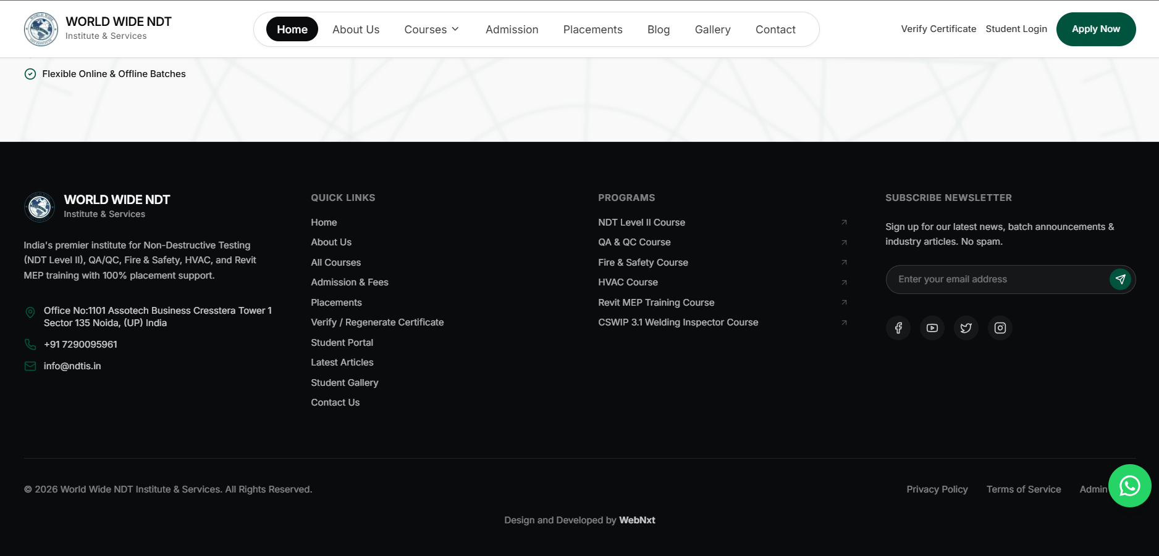
tc02 | Verify Header/Navigation Menu Text Display | To ensure that all primary navigation menu items, specifically "Admission" and "Contact Us", are displayed clearly and completely without being cut off or overlapping. | 1. Navigate to the website's homepage.  2. Inspect the main navigation menu bar located at the top of the page.  3. Check the visibility and readability of the "Admission" and "Contact Us" menu items.  4. Verify that the full text for these labels is visible without truncation or display errors. | FAILED. The menu items "Admission" and "Contact Us" are not displayed properly. The text appears to be merged (e.g., "AdmissionContact") or cut off due to spacing/alignment issues in the header. | Fixed | 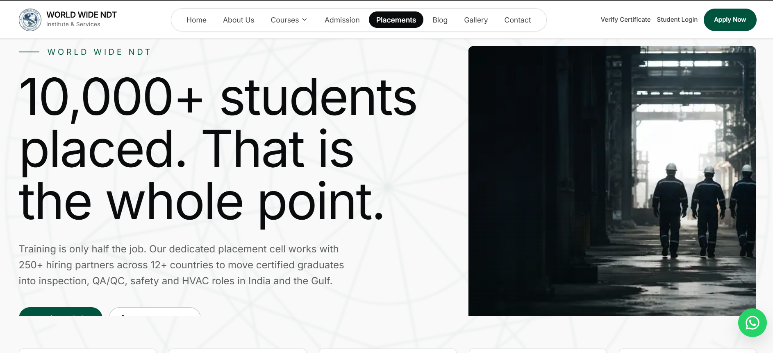
tc03 | Verify Uploaded Image Display in Admin Panel | To ensure that images uploaded by students during the application submission process are correctly displayed and visible in the admin panel. | 1. Log in to the admin panel.  2. Navigate to the "Admission applications" section.  3. Select a specific student application that has uploaded images.  4. View the application details and check for the presence and correct display of the uploaded images.  5. Verify that the images are not broken, missing, or showing placeholders. | FAILED. While submitting the application, images were uploaded, but they are not displaying in the admin panel. The images appear broken, are missing, or are showing placeholders instead of the actual uploaded content. | Fixed | 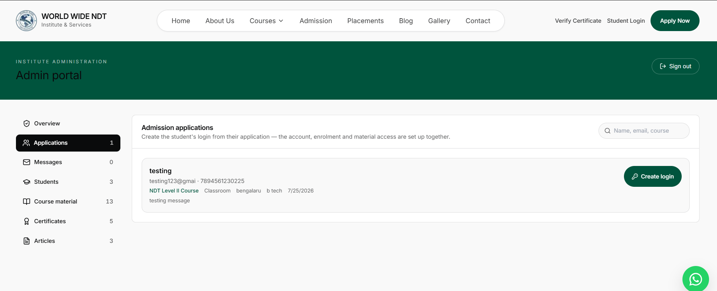
tc04 | Verify Navigation Functionality of Admin Panel Tabs | To ensure that clicking on the admin panel tabs (Applications, Students, Material, Certificates) correctly redirects the user to their respective pages. | 1. Log in to the admin panel.  2. Click on the "Applications" tab.  3. Verify the page redirects to the Applications page.  4. Click on the "Students" tab.  5. Verify the page redirects to the Students page.  6. Click on the "Material" tab.  7. Verify the page redirects to the Material page.  8. Click on the "Certificates" tab.  9. Verify the page redirects to the Certificates page. | FAILED. Clicking on the tabs (Applications, Students, Material, Certificates) does not redirect to the respective pages. The navigation is either unresponsive or redirects to an incorrect/wrong page. | Fixed | 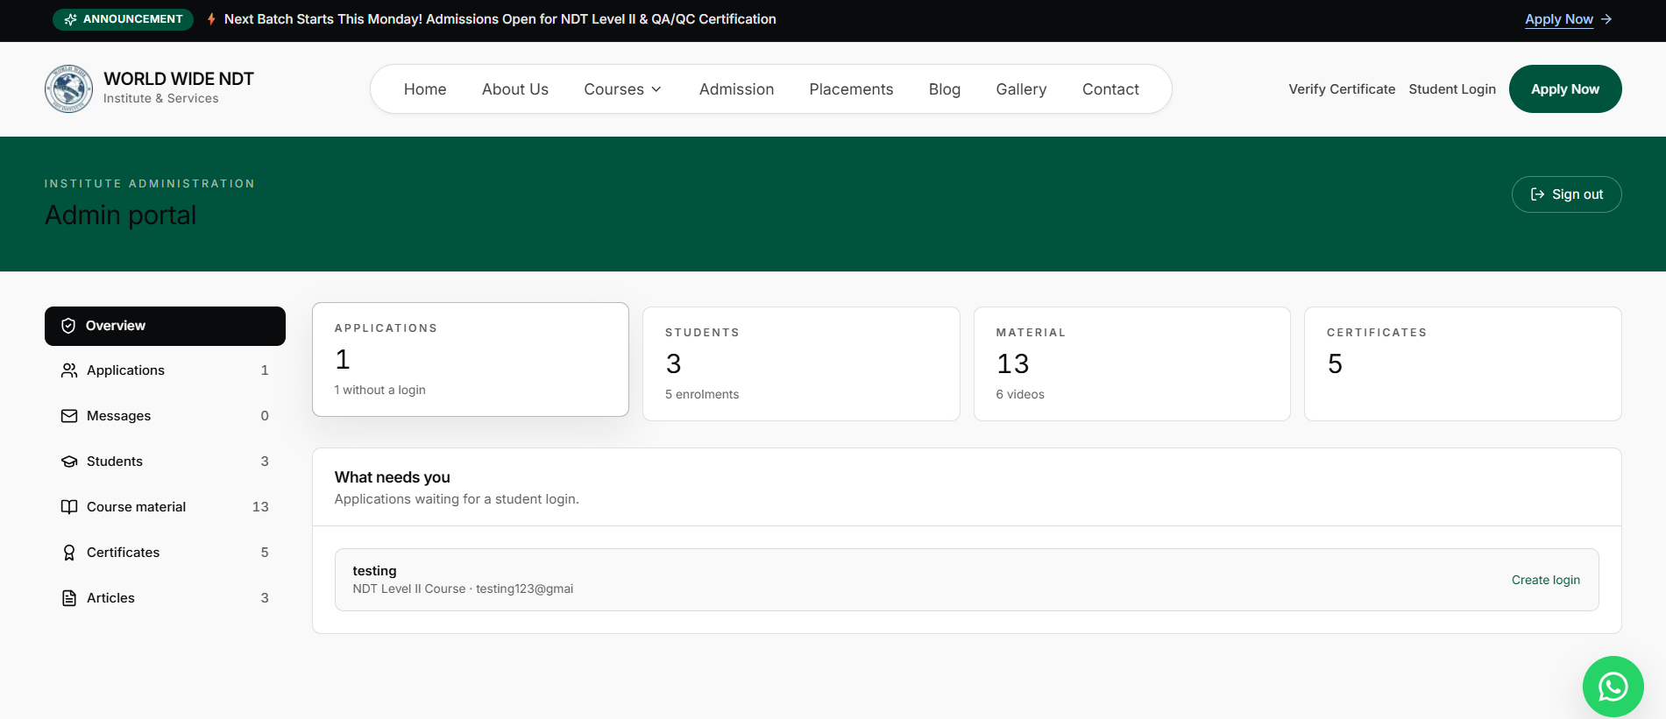
tc05 | Verify Logo Size and Visibility | To ensure that the institute's logo is appropriately sized, clearly visible, and prominently displayed on the website for better brand recognition. | 1. Navigate to the website's homepage.  2. Locate the institute's logo at the top of the page (typically in the header section).  3. Visually inspect the logo's size relative to the rest of the page elements (navigation menu, text, etc.).  4. Check if the logo appears too small, making it difficult to read or recognize.  5. Verify if the logo is properly aligned and not overlapping with other elements. | FAILED. The logo is too small. It appears undersized compared to the surrounding navigation menu and other page elements, making it less prominent and potentially affecting brand visibility. | Fixed | 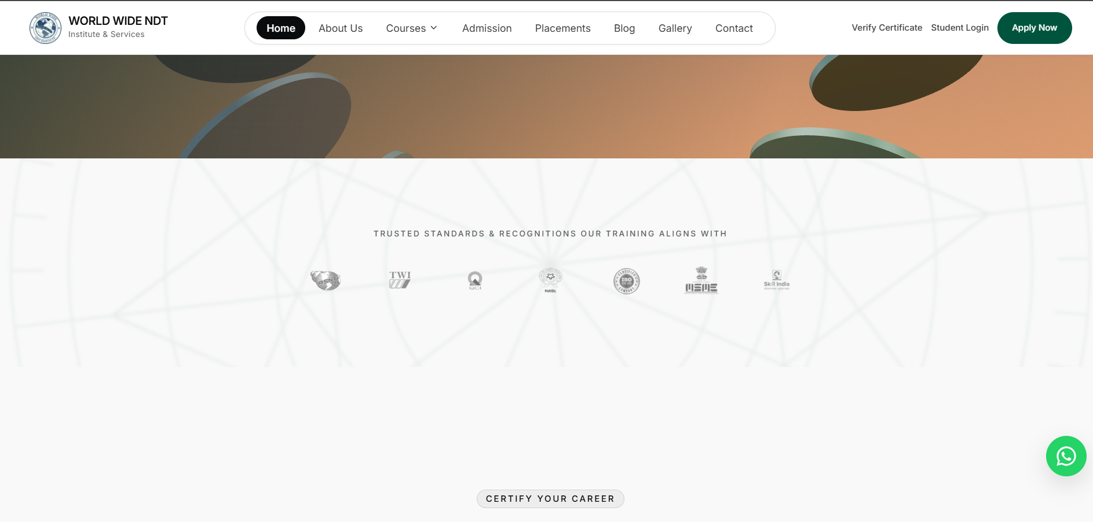
tc06 | Verify Certificate Verification and Download Flow | To ensure that the certificate verification process is simplified by changing the option to just "Verify" first, followed by a separate "Download" option after verification is complete. | 1. Navigate to the "Verify Certificate" page.  2. Enter a valid Certificate number or Enrolment ID in the input field.  3. Click on the "Verify" button (currently labeled "Verify & download").  4. Observe if the certificate details are displayed after verification.  5. Check if a separate "Download" option/button appears after successful verification.  6. Verify that the download functionality works correctly. | FAILED. The current implementation combines "Verify" and "Download" into a single action ("Verify & download"). The requirement is to separate these into two steps: first "Verify" to validate and display the certificate, and then provide a separate "Download" option for the user to download the certificate. | Fixed | 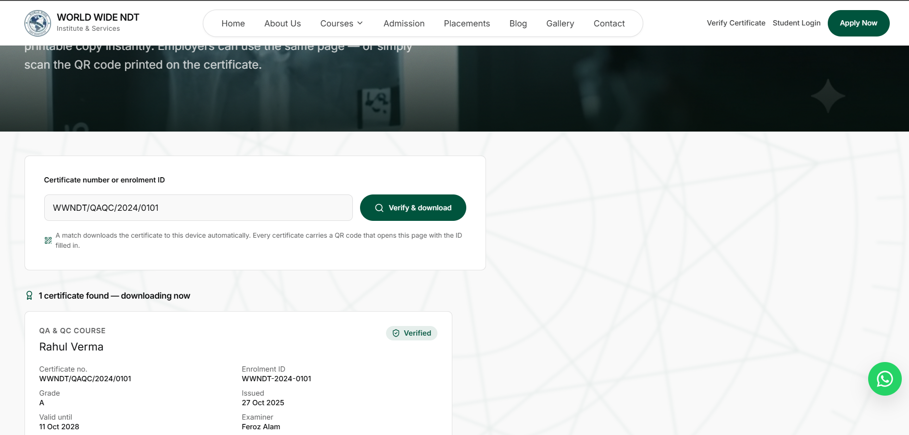
tc07 | Verify Password Visibility Toggle (Eye Icon) in Student Login | To ensure that an eye icon is provided in the password field so that users can toggle and view the password they have entered for better usability and accuracy. | 1. Navigate to the Student Portal / Student Login page.  2. Locate the "Password" input field.  3. Enter a password in the password field (e.g., "password123").  4. Look for an eye icon (👁️) inside or next to the password field.  5. Click on the eye icon to toggle password visibility.  6. Verify that the entered password becomes visible in plain text.  7. Click the eye icon again to hide the password and verify it reverts to masked characters (dots/bullets). | FAILED. The eye icon is missing from the password field. Currently, there is no toggle option available for users to view the password they have entered, which may lead to typing errors and poor user experience. | Fixed | 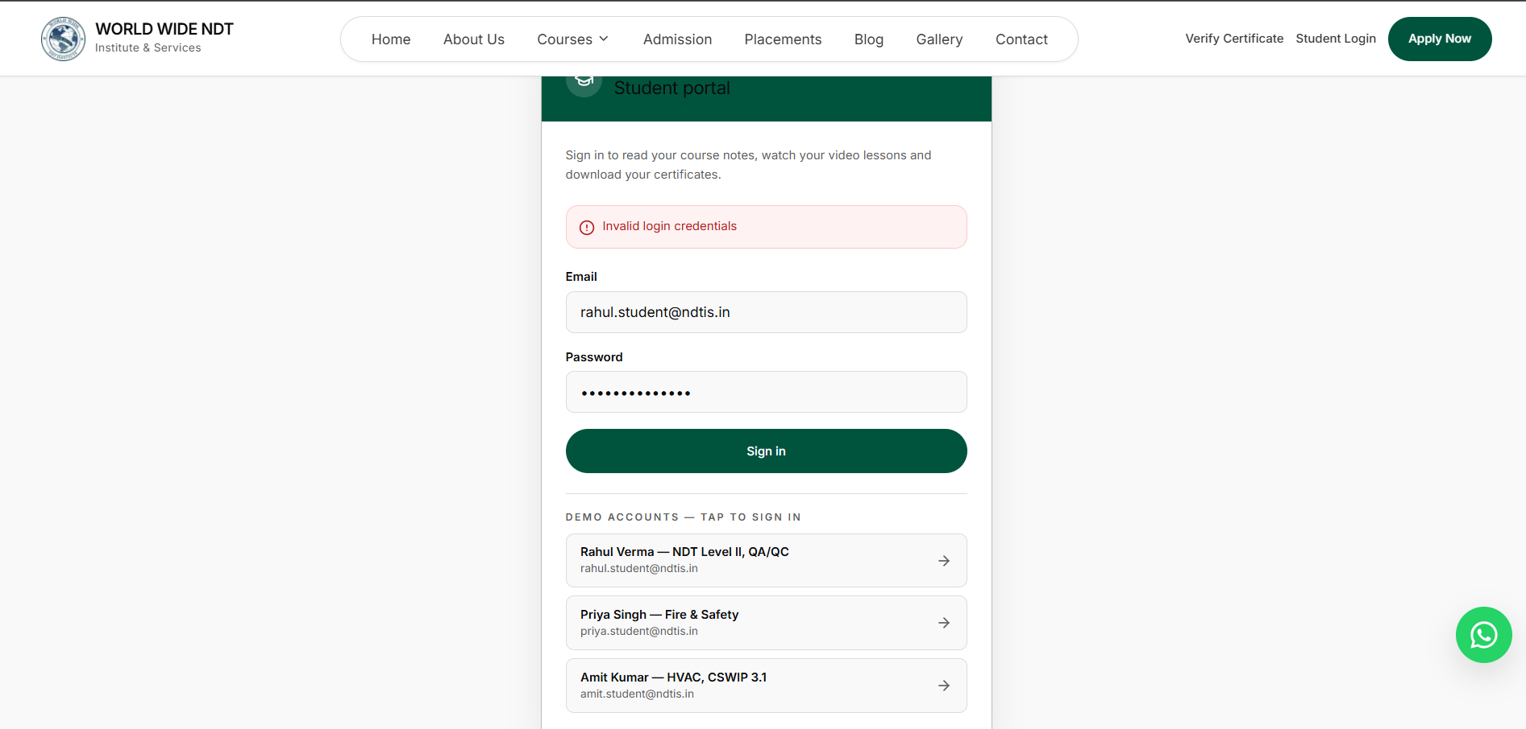
tc08 | Verify Header and Footer Removal from Student Portal and Admin Portal | To ensure that the header (navigation menu) and footer are removed from both the Student Portal and Admin Portal for a cleaner, distraction-free user interface. | 1. Log in to the Student Portal as a student (e.g., Rahul Verma).  2. Check if the main website header (Home, About Us, Courses, etc.) is visible on the dashboard.  3. Scroll down and check if the footer (copyright, links, etc.) is visible.  4. Log in to the Admin Portal as an administrator.  5. Check if the main website header is visible on the admin dashboard.  6. Scroll down and check if the footer is visible on the admin dashboard. | FAILED. The header and footer are still visible in both the Student Portal and Admin Portal. The requirement is to remove them from these portal pages to provide a cleaner interface focused on portal content. | Fixed | 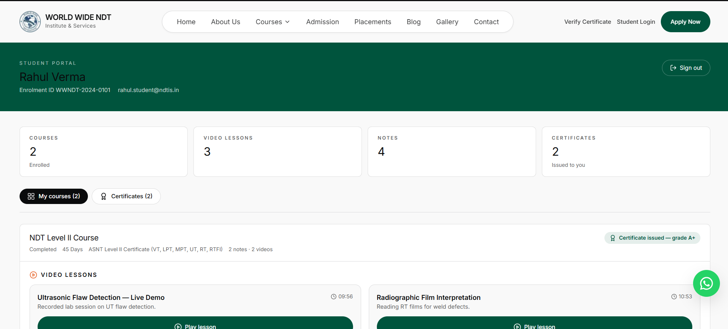
tc09 | Verify Navigation Functionality of Student Portal Dashboard Cards | To ensure that when a student clicks on the dashboard cards/buttons (Courses, Video Lessons, Notes, Certificates), they are redirected to the respective page or section displaying the relevant content. | 1. Log in to the Student Portal as a student.  2. Locate the dashboard cards/sections for "Courses", "Video Lessons", "Notes", and "Certificates".  3. Click on the "Courses" card/button.  4. Verify that the page redirects to the Courses page showing all enrolled courses.  5. Click on the "Video Lessons" card/button.  6. Verify that the page redirects to the Video Lessons page showing all available video lessons.  7. Click on the "Notes" card/button.  8. Verify that the page redirects to the Notes page showing all available notes.  9. Click on the "Certificates" card/button.  10. Verify that the page redirects to the Certificates page showing all issued certificates. | FAILED. Clicking on the dashboard cards (Courses, Video Lessons, Notes, Certificates) does not redirect to the respective pages or sections. The navigation is either unresponsive or does not display the intended content. | Fixed
tc10 | Verify Warning/Error Messages are User-Friendly and Understandable | To ensure that all warning, error, or validation messages displayed to users are clear, simple, and easy to understand, avoiding technical jargon or confusing language. | 1. Navigate to the website and perform actions that trigger warning/error messages (e.g., submit a form with invalid data, enter incorrect login credentials, leave mandatory fields empty).  2. Observe the warning/error message that appears on the screen.  3. Read the message and check if it is written in simple, user-friendly language.  4. Verify that the message clearly explains what went wrong and suggests the corrective action needed.  5. Check that the message does not contain technical jargon (e.g., error codes, database errors, stack traces). | FAILED. The current warning/error messages are not user-friendly. They are either too technical, vague, or confusing, making it difficult for the user to understand the issue and take corrective action (e.g., "Invalid login credentials" is too generic; it should specify if the email or password is incorrect). | Fixed | 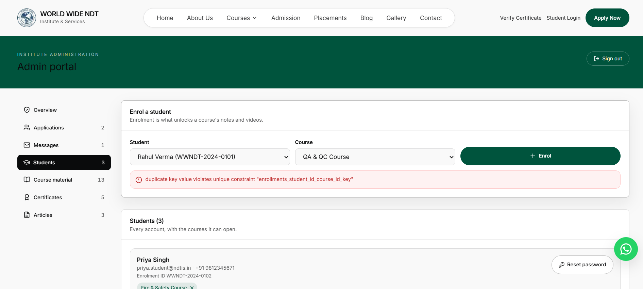
tc11 | Verify Cancel Button Overlap and Functionality | To ensure that the cancel option/button is properly placed, not overlapping with other UI elements, and is clickable so that the user can successfully cancel the action. | 1. Navigate to the page where the cancel option/button is displayed (e.g., modal, form, popup).  2. Visually inspect the position of the cancel button.  3. Check if the cancel button is overlapping with other buttons, text, or UI elements.  4. Try to click on the cancel button.  5. Verify if the cancel action is successfully triggered and the user can cancel the operation. | FAILED. The cancel option is overlapping with other UI elements, making it difficult or impossible for the user to click on it. The user is not able to cancel the option due to this UI overlap issue. | Fixed | 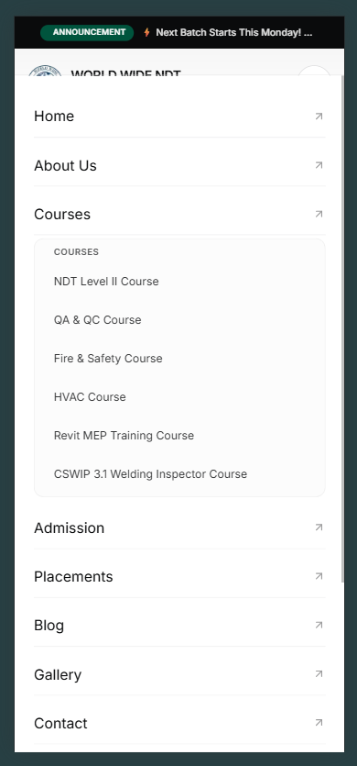
tc12 | Verify Video Playback Functionality in Student Portal | To ensure that videos uploaded from the admin panel for a specific course (QA/QC Course) are playable from the student portal without any errors. | 1. Log in to the admin panel.  2. Navigate to the course material section and upload a new video for the QA/QC Course (e.g., video named "Test").  3. Log in to the Student Portal as a student enrolled in the QA/QC Course.  4. Navigate to the Video Lessons section for the QA/QC Course.  5. Locate the newly uploaded video ("Test").  6. Click on the play button to start the video.  7. Observe if the video plays successfully without any errors, buffering, or crashes. | FAILED. The videos are not playing from the student portal. Even after uploading a new video ("Test") from the admin panel for the QA/QC Course, the video does not play. The video may show a black screen, loading error, or remains unresponsive. | Fixed | 